Kubernetes Task-04

Task Title
Kubernetes Deployment Strategies, Updates, and Resource Management
Objective
The objective of this exercise is to understand and implement key Kubernetes concepts related to application deployment, update strategies, and resource control. This includes working with Deployments using different update mechanisms, managing rollouts and rollbacks, configuring resource requests and limits, controlling revision history, pausing/resuming updates, and observing scheduler behavior.
Prerequisites
• A working Kubernetes cluster (Minikube / Kubeadm / Cloud-based cluster)
• kubectl installed and configured
• Basic understanding of:
• Pods
• Deployments
• ReplicaSets
• YAML configuration files
• Container images accessible from a registry (e.g., nginx)
• Access to cluster nodes (for scheduler observation tasks)

- Deploy an application using a Deployment with 3 replicas and a rolling update strategy.
Steps Performed
• Created Deployment YAML File
• Created a file named rolling.yaml
• Added Deployment Configuration
apiVersion: apps/v1
kind: Deployment
metadata:
name: rolling-nginx
spec:
replicas: 3
strategy:
type: Rolling Update
rollingUpdate:
maxUnavailable: 1
maxSurge: 1
selector:
matchLabels:
app: nginx-roll
template:
metadata:
labels:
app: nginx-roll
spec:
containers:
- name: nginx
image: nginx:1.25
ports:
- containerPort: 80
• Defined Deployment Resource
• Set apiVersion: apps/v1
• Set kind: Deployment
• Assigned name: rolling-nginx
• Configured Replica Count
• Set replicas: 3
• Configured Rolling Update Strategy
• Set strategy.type: RollingUpdate
• Set maxUnavailable: 1
• Set maxSurge: 1
• Defined Label Selector
• Added matchLabels: app: nginx-roll
• Defined Pod Template Labels
• Added labels: app: nginx-roll
• Configured Container Specification
• Set container name: nginx
• Set container image: nginx:1.25
• Exposed containerPort: 80
• Applied Deployment Configuration
• Executed kubectl apply -f rolling.yaml
• Verified Deployment Creation
• Executed kubectl get deployments
• Verified Running Pods
• Executed kubectl get pods
• Confirmed 3 pods in Running state
• Performed Rolling Update (If Tested)
• Updated container image in YAML
• Re-applied configuration using kubectl apply -f rolling.yaml
• Monitored Rollout Status
• Executed kubectl rollout status deployment rolling-nginx

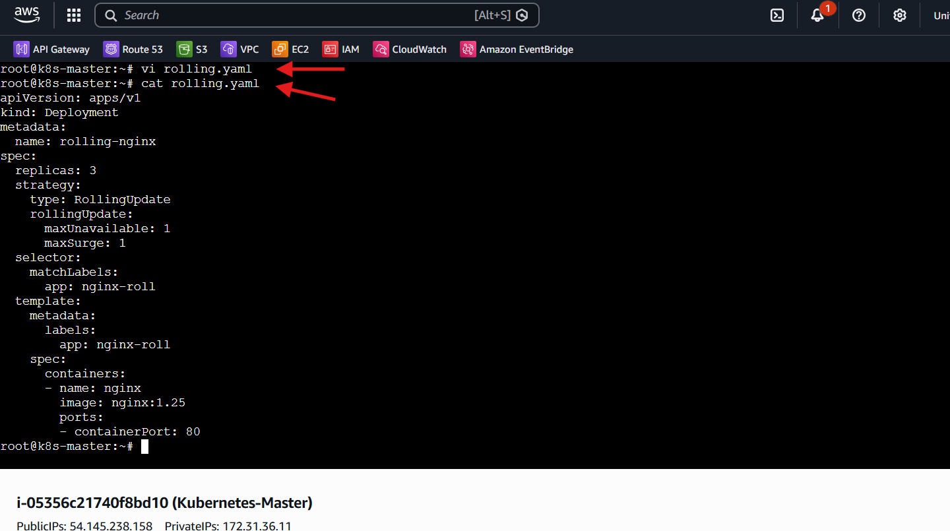
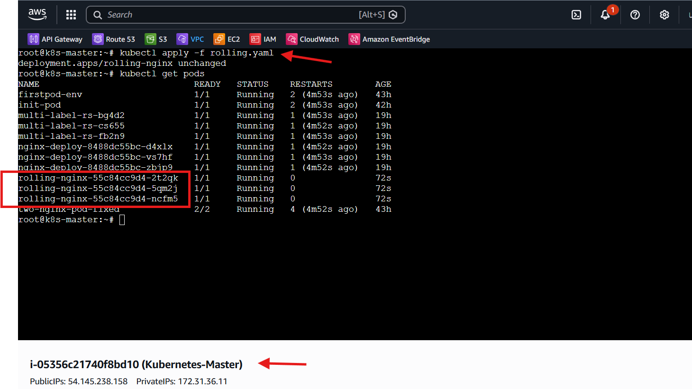

- Configure a Deployment with a Recreate strategy and observe the downtime.
Steps Performed
• Created Deployment YAML File
• Created a file named recreate.yaml
• Added Deployment Configuration
apiVersion: apps/v1
kind: Deployment
metadata:
name: recreate-nginx
spec:
replicas: 3
strategy:
type: Recreate
selector:
matchLabels:
app: nginx-rec
template:
metadata:
labels:
app: nginx-rec
spec:
containers:
- name: nginx
image: nginx:1.25
ports:
- containerPort: 80
• Defined Deployment Resource
• Set apiVersion: apps/v1
• Set kind: Deployment
• Assigned name: recreate-nginx
• Configured Replica Count
• Set replicas: 3
• Configured Update Strategy
• Set strategy.type: Recreate
• Defined Label Selector
• Added matchLabels: app: nginx-rec
• Defined Pod Template Labels
• Added labels: app: nginx-rec
• Configured Container Specification
• Set container name: nginx
• Set container image: nginx:1.25
• Exposed containerPort: 80
• Applied Deployment Configuration
• Executed kubectl apply -f recreate.yaml
• Verified Deployment Creation
• Executed kubectl get deployments
• Verified Running Pods
• Executed kubectl get pods
• Confirmed 3 pods in Running state
• Triggered Application Update
• Executed
kubectl set image deployment/recreate-nginx nginx=nginx:1.26
• Observed Recreate Strategy Behavior
• Kubernetes terminated all existing pods first
• Temporary downtime occurred (no pods running)
• Verified New Pods Creation
• Executed kubectl get pods -w
• Observed old pods terminating → new pods starting
• Confirmed Downtime Scenario
• Application became unavailable during pod termination phase
• Availability restored after new pods reached Running state
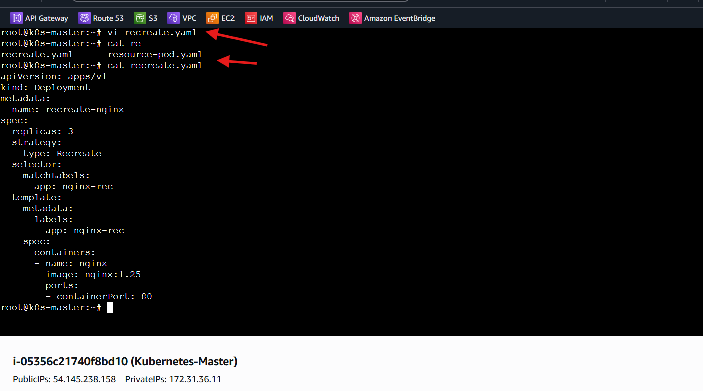
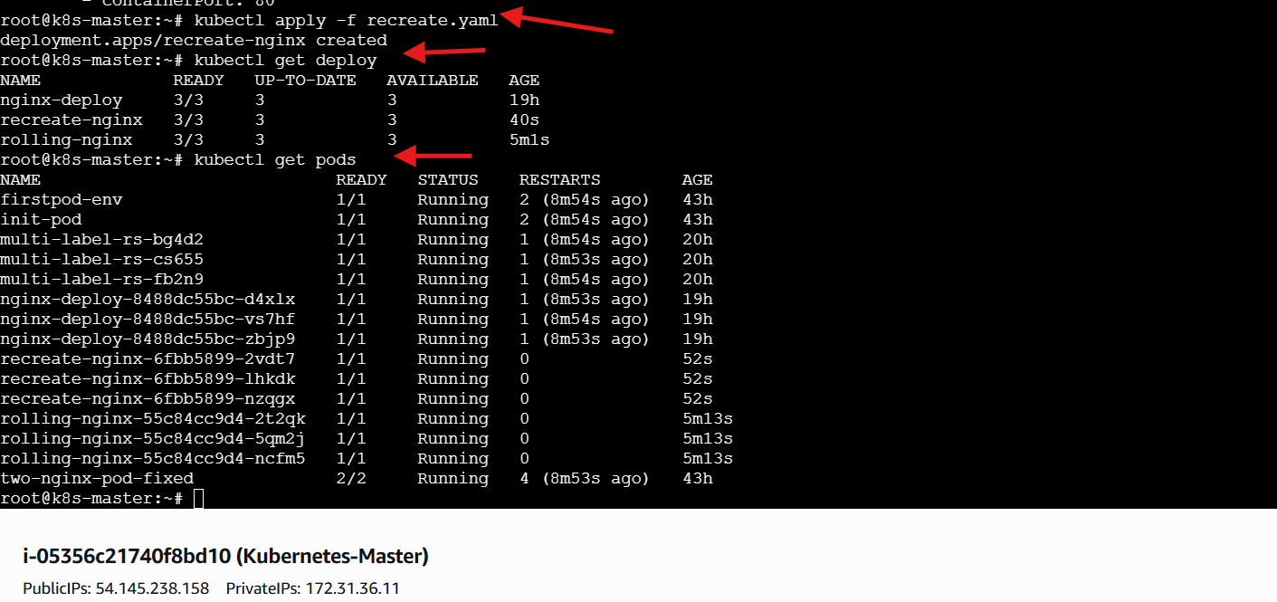
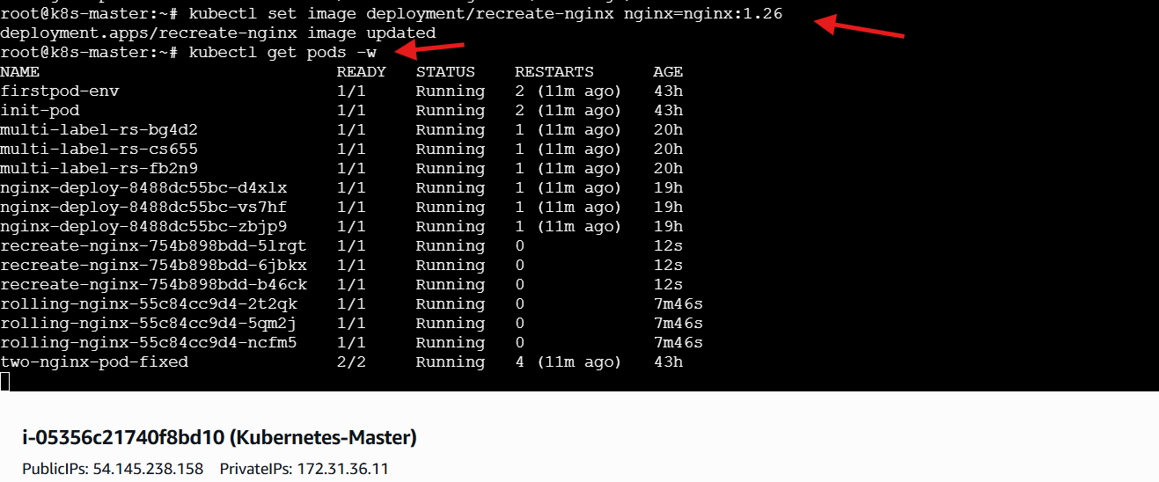
- Update an existing Deployment and perform a rollback to the previous version.
Steps Performed
• Updated Deployment Image
• Executed command:
kubectl set image deployment/rolling-nginx nginx=nginx:1.26
• Verified Rollout Status
• Executed command:
kubectl rollout status deployment/rolling-nginx
• Observed successful rollout
• Checked Rollout History
• Executed command:
kubectl rollout history deployment/rolling-nginx
• Observed multiple revisions
• Performed Rollback
• Executed command:
kubectl rollout undo deployment/rolling-nginx
• Verified Rollback Completion
• Observed Deployment rolled back successfully
• Validated Deployment State
• Executed command:
kubectl get deployments
• Confirmed desired replicas available
• Inspected Deployment Details
• Executed command:
kubectl describe deployment rolling-nginx
• Observed Key Deployment Information
• StrategyType: RollingUpdate
• RollingUpdateStrategy:
• maxUnavailable: 1
• maxSurge: 1
• Replicas:
• Desired: 3
• Updated: 3
• Available: 3
• Unavailable: 0
• Confirmed Successful Rollback Scenario
• Deployment reverted to previous image version
• Application remained available during rollback due to RollingUpdate strategy

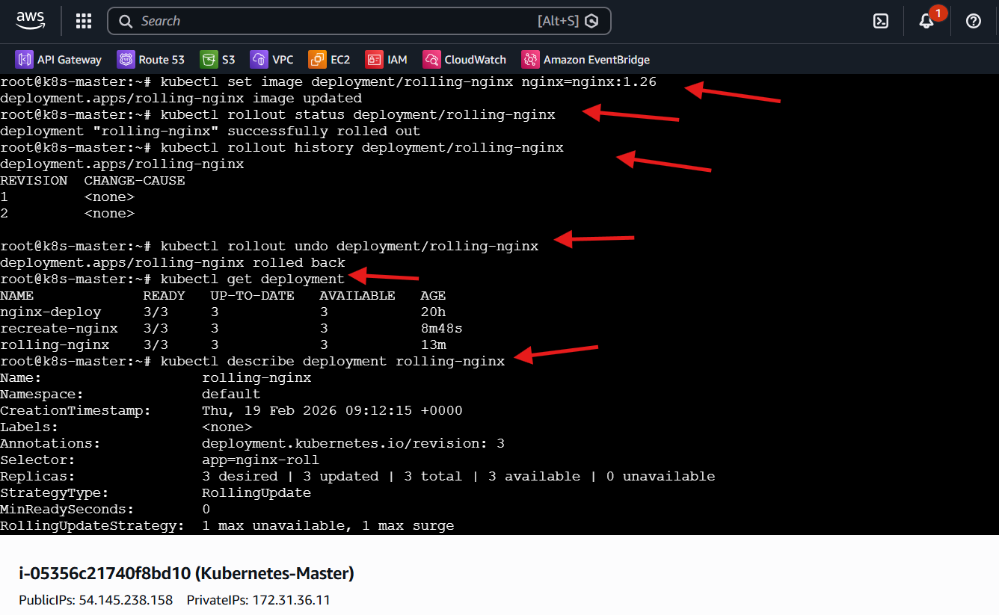

- Modify a Deployment to add resource requests and limits for CPU and memory.
Steps Performed
• Modified Deployment YAML File
• Edited the file resource-nginx.yaml
• Updated Deployment Configuration with Resources
apiVersion: apps/v1
kind: Deployment
metadata:
name: resource-nginx
spec:
replicas: 2
selector:
matchLabels:
app: nginx-res
template:
metadata:
labels:
app: nginx-res
spec:
containers:
- name: nginx
image: nginx
resources:
requests:
memory: "128Mi"
cpu: "200m"
limits:
memory: "256Mi"
cpu: "500m"
• Defined Resource Requests
• Memory request: 128Mi
• CPU request: 200m
• Defined Resource Limits
• Memory limit: 256Mi
• CPU limit: 500m
• Applied Updated Deployment
• Executed command:
kubectl apply -f resource-nginx.yaml
• Verified Deployment Status
• Executed command:
kubectl get deployments
• Verified Pods Creation
• Executed command:
kubectl get pods
• Inspected Pod Configuration
• Executed command:
kubectl describe pod <resource-nginx-pod-name>
• Validated Resource Configuration
• Confirmed Requests section displayed
• Confirmed Limits section displayed
• Verified CPU and memory values correctly applied
• Observed Scheduling Behavior
• Kubernetes scheduled pods based on defined requests
• Limits enforced at container runtime
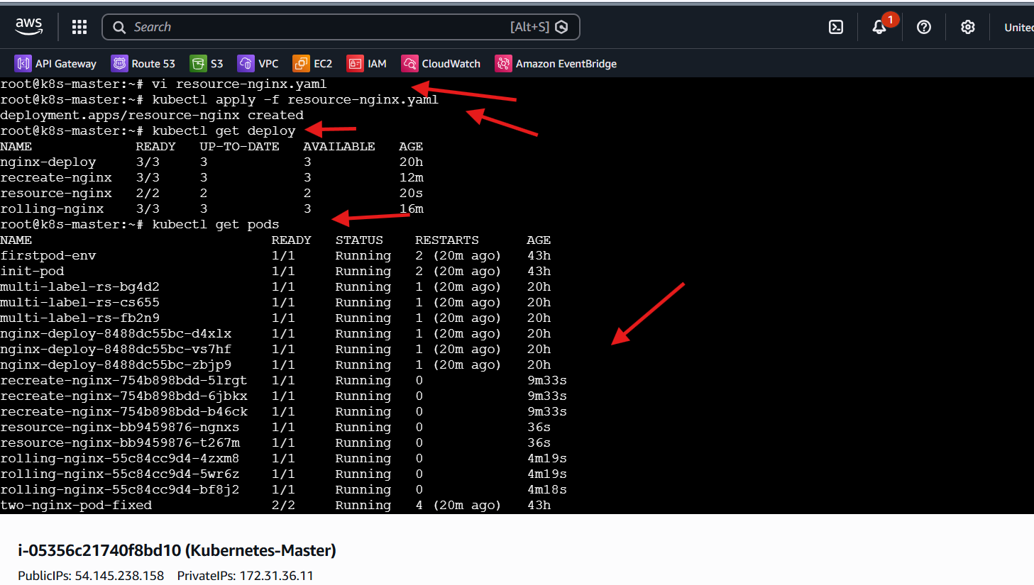
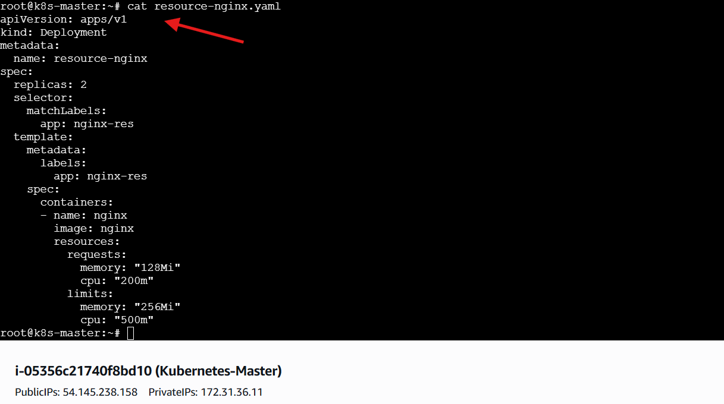
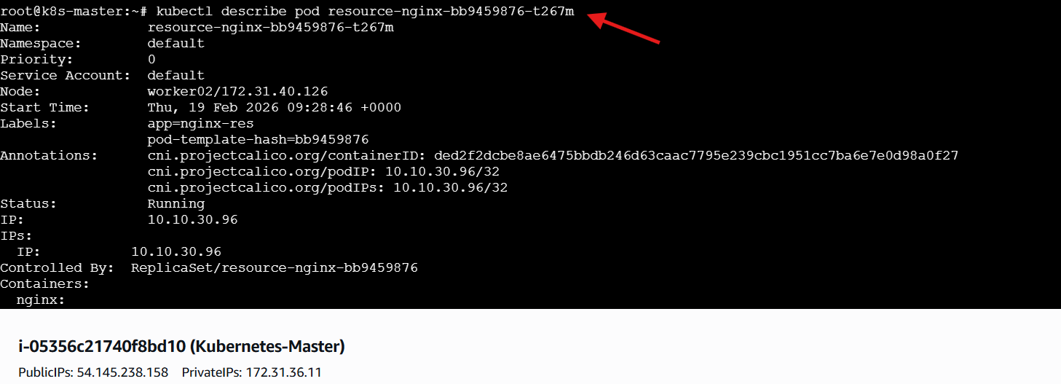
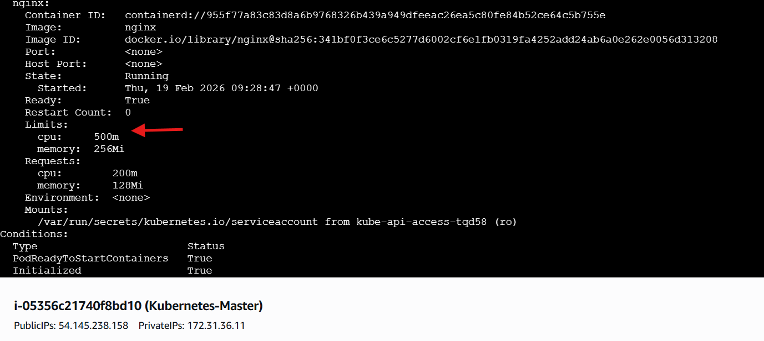

- Create a Deployment with MaxSurge and MaxUnavailable configurations.
Steps Performed
• Created Deployment YAML File
• Created a file named surge-nginx.yaml
• Added Deployment Configuration
apiVersion: apps/v1
kind: Deployment
metadata:
name: surge-nginx
spec:
replicas: 4
strategy:
type: RollingUpdate
rollingUpdate:
maxSurge: 1
maxUnavailable: 1
selector:
matchLabels:
app: nginx-surge
template:
metadata:
labels:
app: nginx-surge
spec:
containers:
- name: nginx
image: nginx
ports:
- containerPort: 80
• Configured Replica Count
• Set replicas: 4
• Configured Rolling Update Parameters
• Set maxSurge: 1
• Set maxUnavailable: 1
• Applied Deployment Configuration
• Executed command:
kubectl apply -f surge-nginx.yaml
• Verified Deployment Creation
• Executed command:
kubectl get deployments
• Observed Deployment surge-nginx with 4 replicas
• Verified Pods Creation
• Executed command:
kubectl get pods
• Confirmed 4 pods in Running state
• Triggered Rolling Update
• Executed command:
kubectl set image deployment/surge-nginx nginx=nginx:1.26
• Observed MaxSurge Behavior
• Kubernetes temporarily created one extra pod
• Total pods briefly increased to 5
• Observed MaxUnavailable Behavior
• At most one pod terminated at a time
• Verified Update Progression
• Executed command:
kubectl get pods -w
• Observed pods terminating and recreating gradually
• Validated Controlled Rolling Update
• Update completed without full downtime
• Availability maintained according to surge/unavailable settings
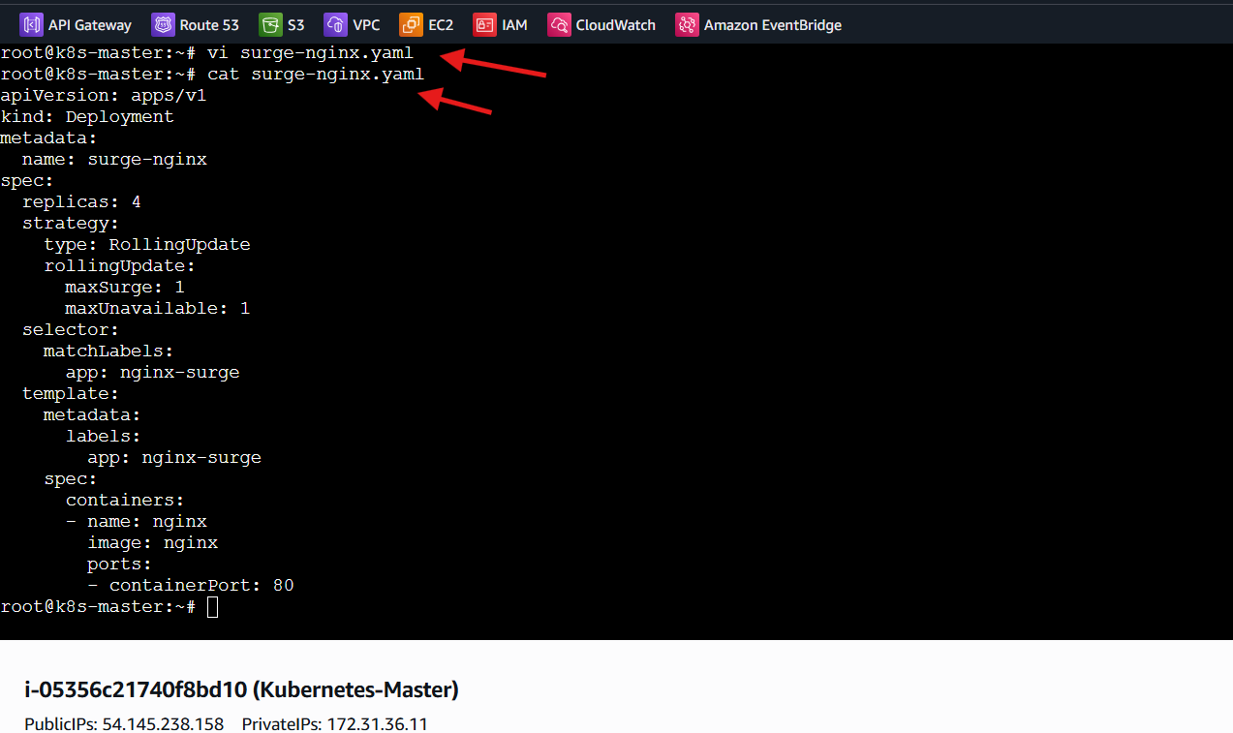
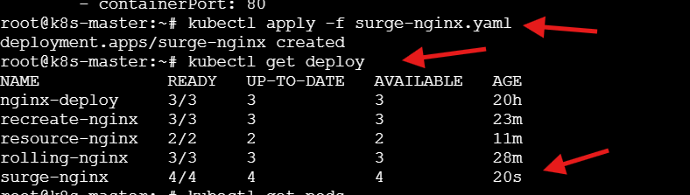
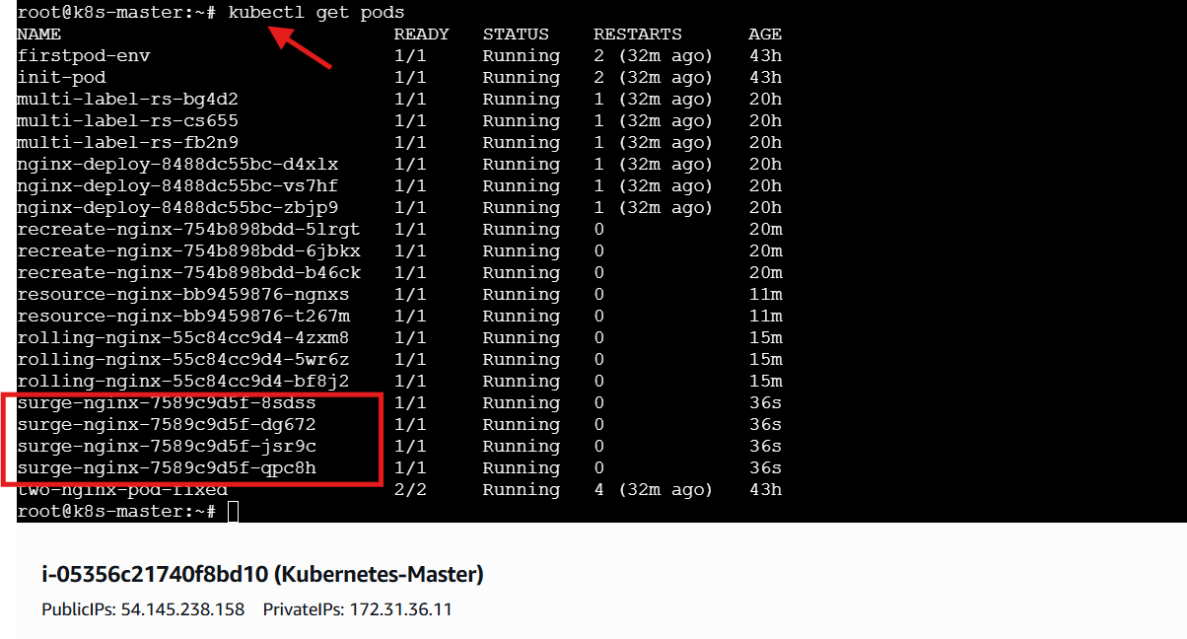
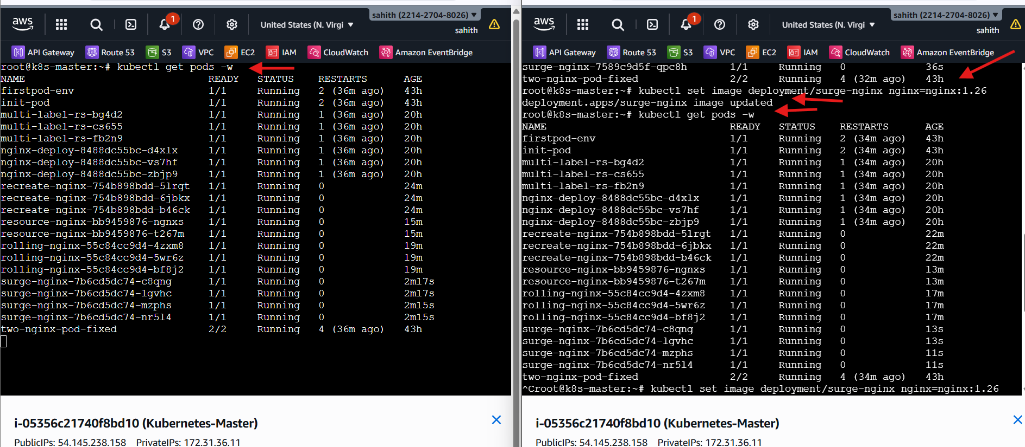

- Set up a Deployment with a custom revision history limit.
Steps Performed
• Created Deployment YAML File
• Created a file named history-nginx.yaml
• Added Deployment Configuration
apiVersion: apps/v1
kind: Deployment
metadata:
name: history-nginx
spec:
revisionHistoryLimit: 3
replicas: 2
selector:
matchLabels:
app: nginx-hist
template:
metadata:
labels:
app: nginx-hist
spec:
containers:
- name: nginx
image: nginx
ports:
- containerPort: 80
• Configured Revision History Limit
• Set revisionHistoryLimit: 3
• Configured Replica Count
• Set replicas: 2
• Applied Deployment Configuration
• Executed command:
kubectl apply -f history-nginx.yaml
• Verified Deployment Creation
• Executed command:
kubectl get deployments
• Verified Pods Creation
• Executed command:
kubectl get pods
• Confirmed pods in Running state
• Triggered Multiple Updates
• Executed sequential image updates:
• kubectl set image deployment/history-nginx nginx=nginx:1.25
• kubectl set image deployment/history-nginx nginx=nginx:1.26
• kubectl set image deployment/history-nginx nginx=nginx:1.27
• kubectl set image deployment/history-nginx nginx=nginx:1.28
• Verified ReplicaSets
• Executed command:
kubectl get rs
• Observed Revision Cleanup Behavior
• Older ReplicaSets automatically removed
• Only last 3 revisions retained
• Verified Rollout History
• Executed command:
kubectl rollout history deployment/history-nginx
• Validated Revision History Limit
• Confirmed only limited revisions available
• Demonstrated Kubernetes revision retention control
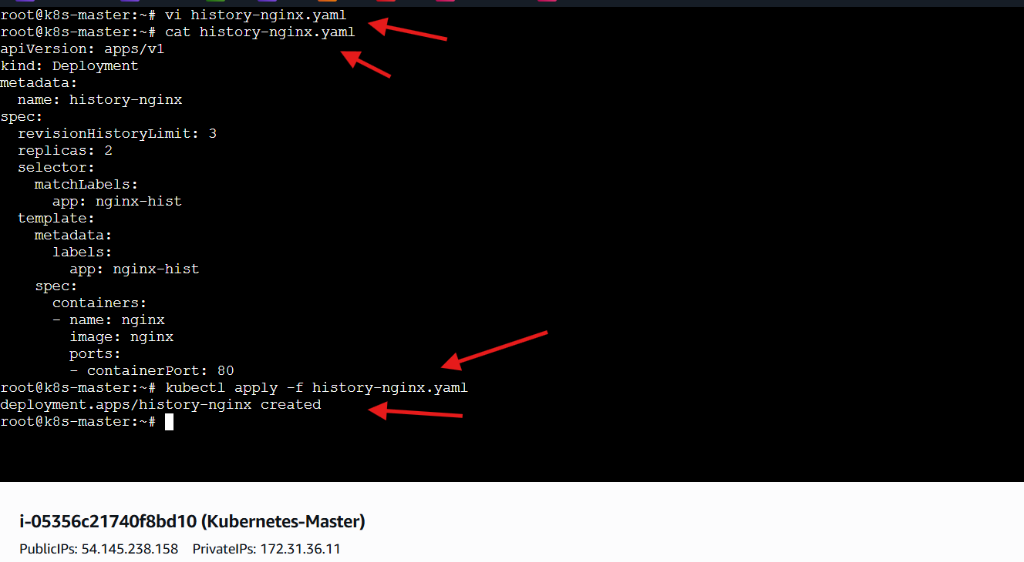
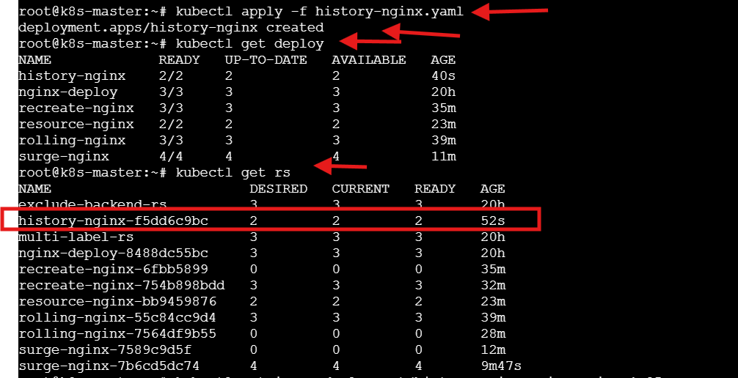
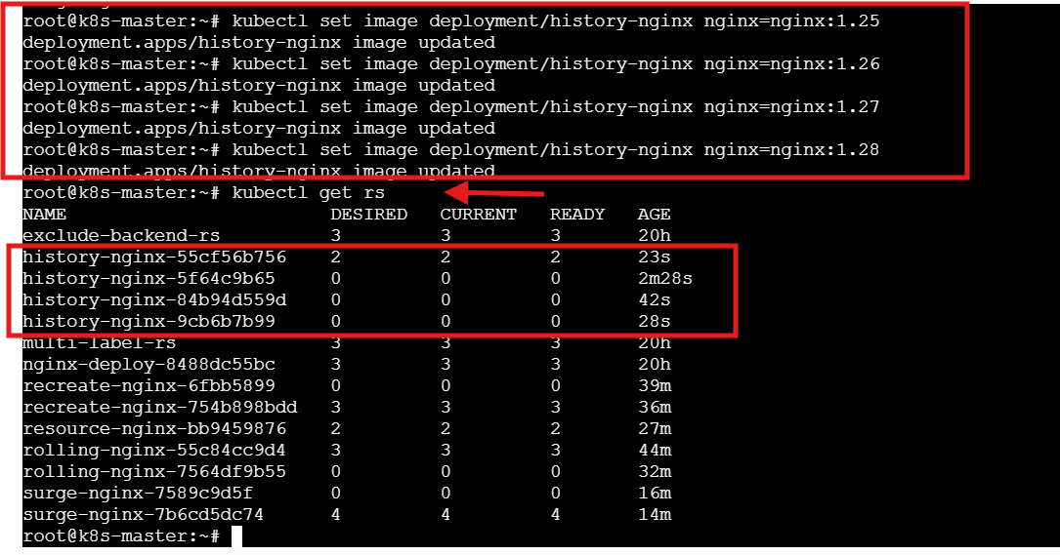
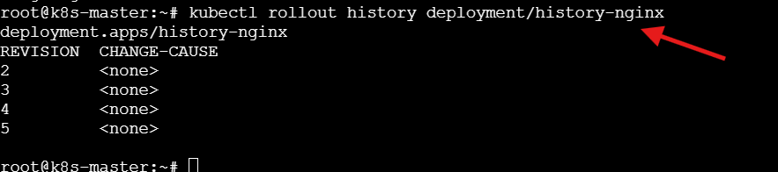

- Pause a Deployment during an update, and then resume it.
Steps Performed
• Paused the Deployment
• Executed command:
kubectl rollout pause deployment/rolling-nginx
• Triggered an Update While Paused
• Executed command:
kubectl set image deployment/rolling-nginx nginx=nginx:1.27
• Verified Pods State During Pause
• Executed command:
kubectl get pods
• Observed that pods were not updated immediately
• Confirmed Deployment Was Paused
• Update registered but rollout did not proceed
• Resumed the Deployment
• Executed command:
kubectl rollout resume deployment/rolling-nginx
• Verified Rollout Progress
• Executed command:
kubectl rollout status deployment/rolling-nginx
• Observed Rolling Update Execution
• Pods updated gradually after resume
• Validated Deployment Behavior
• Pause prevented rollout execution
• Resume restarted the rolling update process
• Demonstrated controlled deployment update management
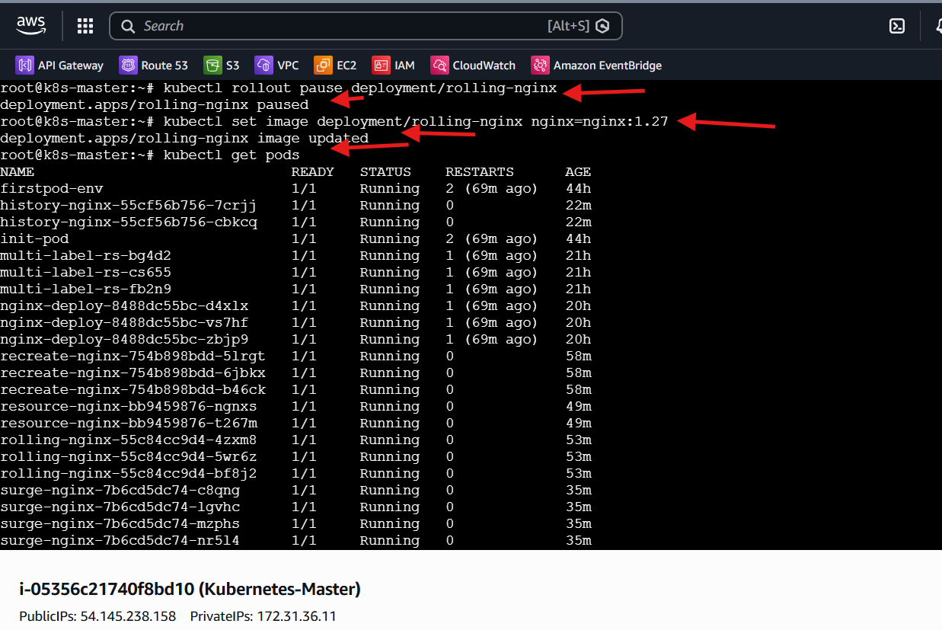
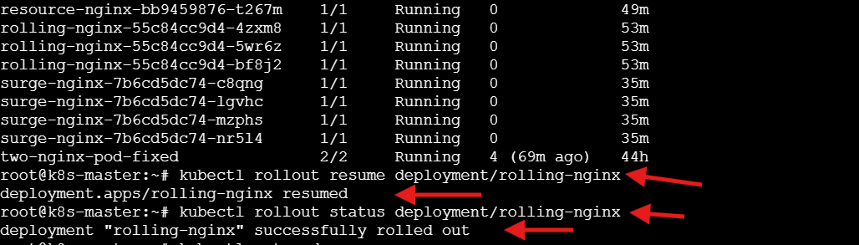

- Create a pod using resource requests for memory and CPU, and observe how the scheduler assigns it to a node.
Steps Performed
• Checked Node Assignment of Existing Pods
• Executed command:
kubectl get pods -o wide
• Observed how pods are distributed across worker nodes
• Created Pod YAML File
• Created a file named pod.yaml
• Added Pod Configuration with Resource Requests
apiVersion: v1
kind: Pod
metadata:
name: resource-pod
spec:
containers:
- name: nginx
image: nginx
resources:
requests:
memory: "256Mi"
cpu: "500m"
limits:
memory: "512Mi"
cpu: "1"
• Configured Resource Requests
• Memory request: 256Mi
• CPU request: 500m
• Configured Resource Limits
• Memory limit: 512Mi
• CPU limit: 1
• Applied Pod Configuration
• Executed command:
kubectl apply -f pod.yaml
• Verified Pod Creation
• Executed command:
kubectl get pods
• Observed Scheduler Decision
• Executed command:
kubectl get pods -o wide
• Identified the node where resource-pod was scheduled
• Inspected Pod Details
• Executed command:
kubectl describe pod resource-pod
• Validated Resource Constraints
• Confirmed Requests section
• Confirmed Limits section
• Observed Scheduling Behavior
• Scheduler selected a node with sufficient available CPU & memory
• Demonstrated how resource requests influence pod placement
• Key Observation
• Requests determine scheduling eligibility
• Limits enforce runtime resource boundaries
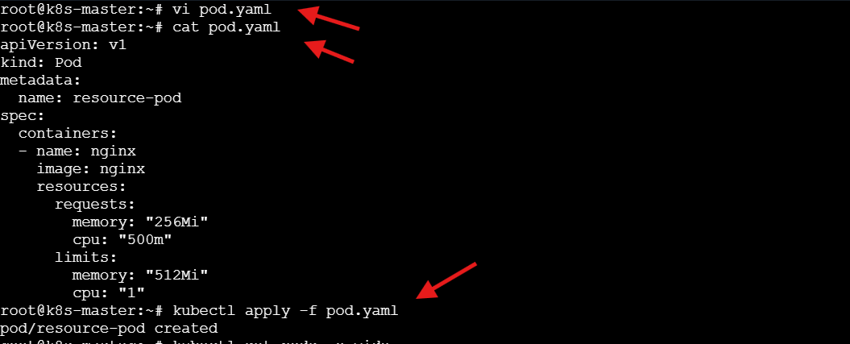
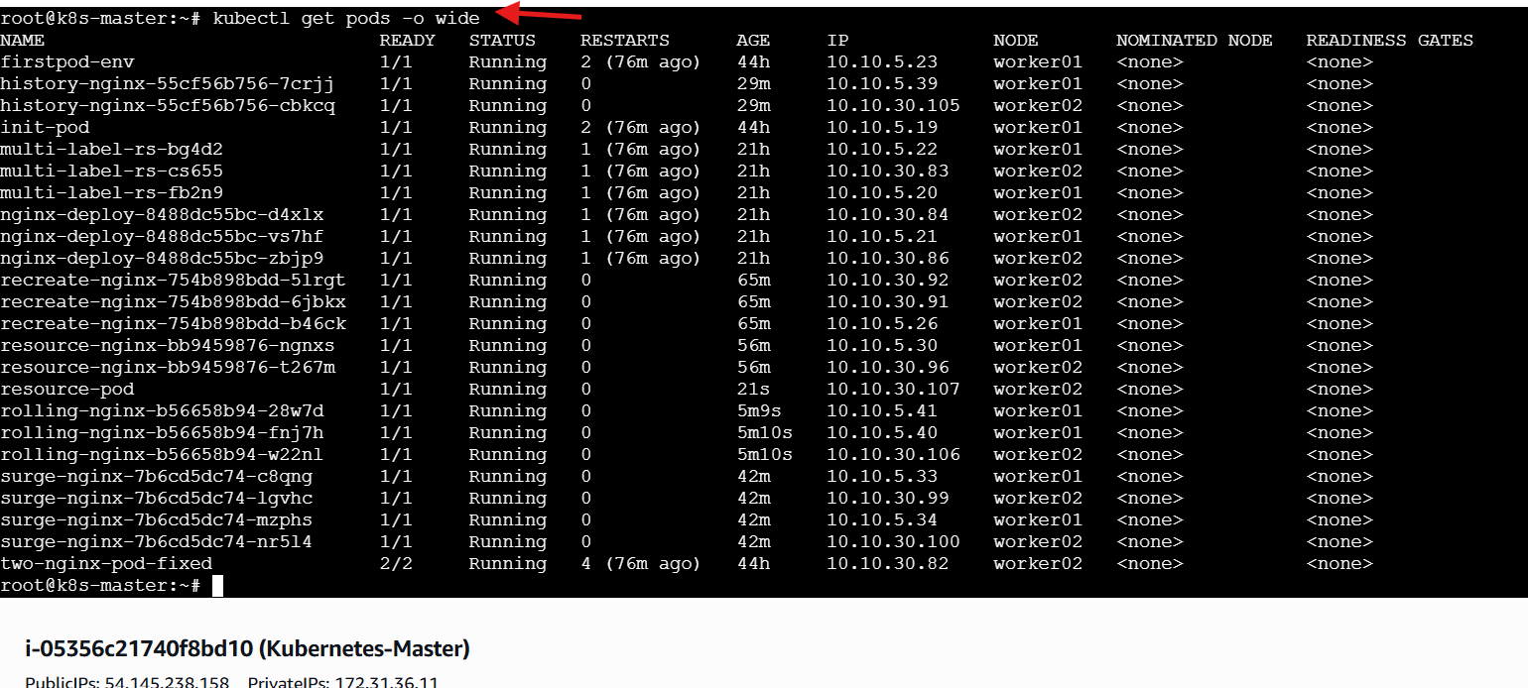
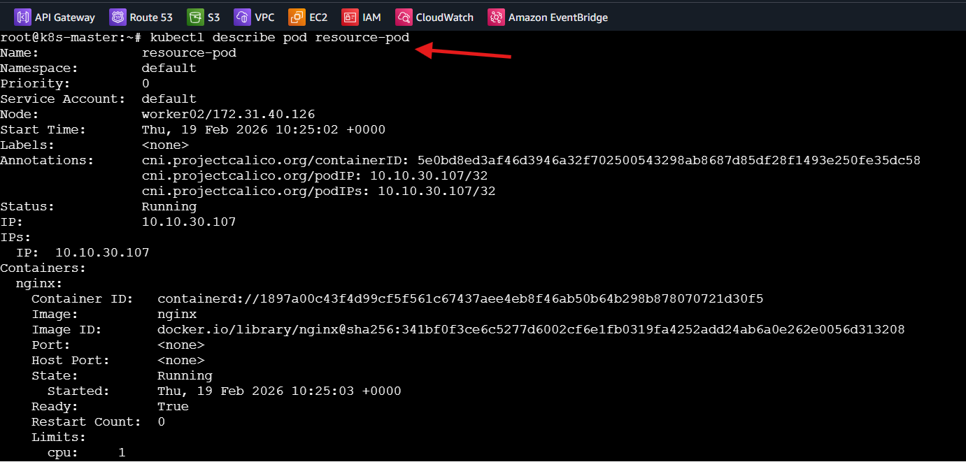
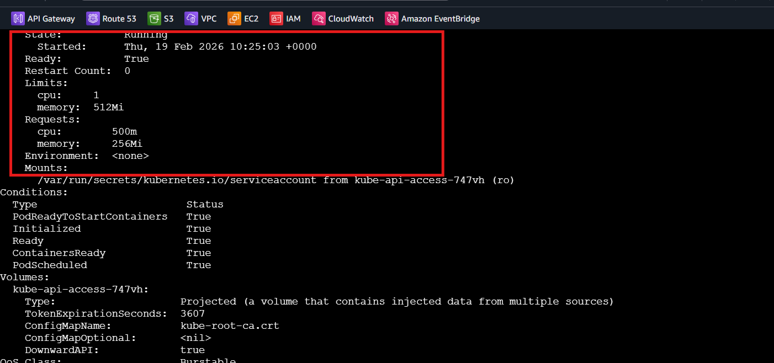

Overall Task Conclusion:
Through this set of exercises, multiple essential Kubernetes deployment and management features were explored:
• Deployments were created with varying replica counts to ensure high availability and scalability.
• RollingUpdate strategy demonstrated controlled updates with minimal downtime.
• Recreate strategy highlighted application downtime during full pod replacement.
• Rollbacks validated Kubernetes’ ability to revert to stable revisions.
• Resource requests and limits enforced workload governance and predictable scheduling.
• MaxSurge and MaxUnavailable settings illustrated fine-grained update control.
• Revision history limits showed how Kubernetes manages ReplicaSet retention.
• Pause and resume functionality demonstrated deployment lifecycle control.
• Scheduler behavior was observed based on resource constraints.
Overall, these tasks reinforce practical understanding of Kubernetes application lifecycle management, reliability mechanisms, and cluster resource optimization — all critical for production-grade container orchestration.

